From the above given tables write a SQL query to find the salesperson(s) and the customer(s) represented here. Return the Customer Name, City, Salesman, commission.

CUSTOMER

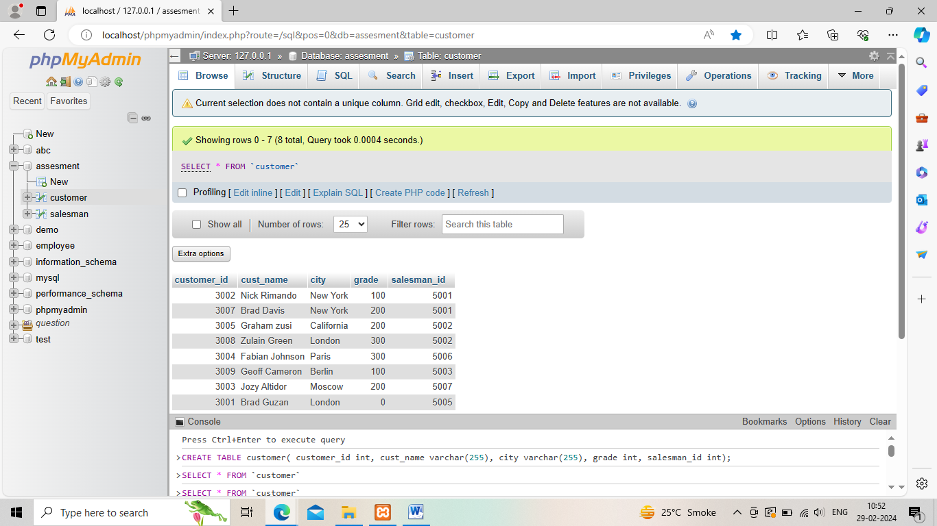

SALESMAN

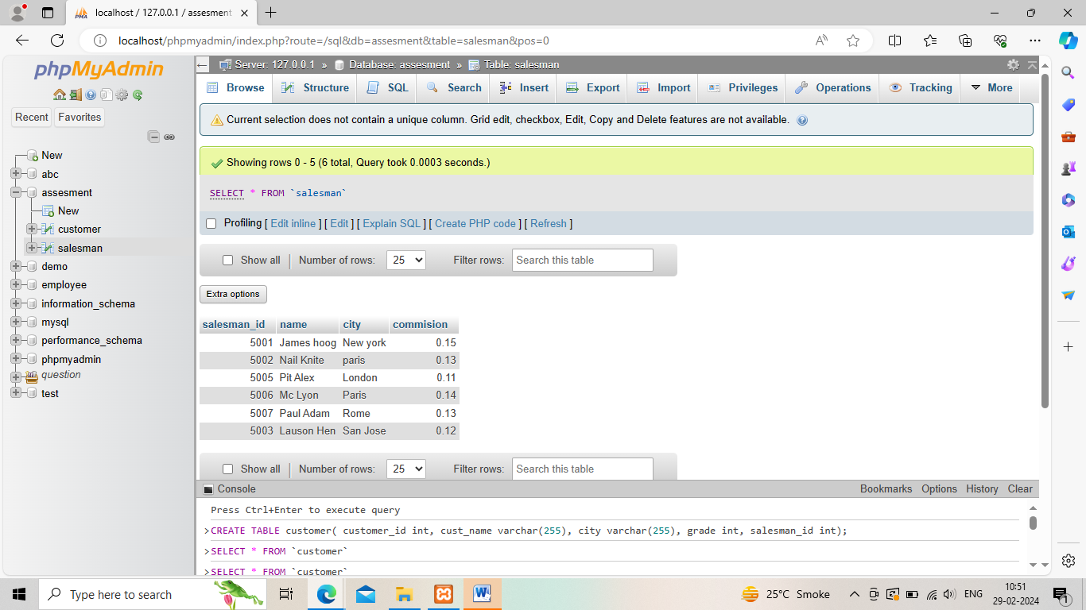

OUTPUT:

